LAB EXPERIMENT RECORD

Set 14: Survey Results

Department | AIML
Course Code / Course Name | DSA0602 / Data Handling and Visualization
Experiment | Data Visualization using Tableau
Name | S.Naveen Kumar
Register Number | 192425176
Date | 8 October 2026
Day | Thursday

Aim
To visualize survey results using a stacked bar chart, a radar chart and a table, and to build an interactive Tableau dashboard for exploring the survey responses.

Dataset: Survey Results

Respondent | Question 1 | Question 2 | Question 3
1 | A | B | C
2 | B | A | D
3 | C | A | B

PROGRAM 1: Stacked Bar Chart for Question 1
Create a stacked bar chart to display the distribution of answers for Question 1. Label the chart elements.

Steps in Tableau:
- Connect to the survey data file and open a new sheet named "Q1 Stacked Bar".
- Drag Question 1 to Color (this splits the bar by answer A, B and C).
- Drag Respondent to Rows and change it to Count (CNT) so the bar height shows the number of respondents.
- Drag Question 1 to Label (or Count to Label) to show the value inside each segment.
- Set the title to "Distribution of Answers for Question 1", label the Y-axis "Number of Respondents" and show the colour legend.

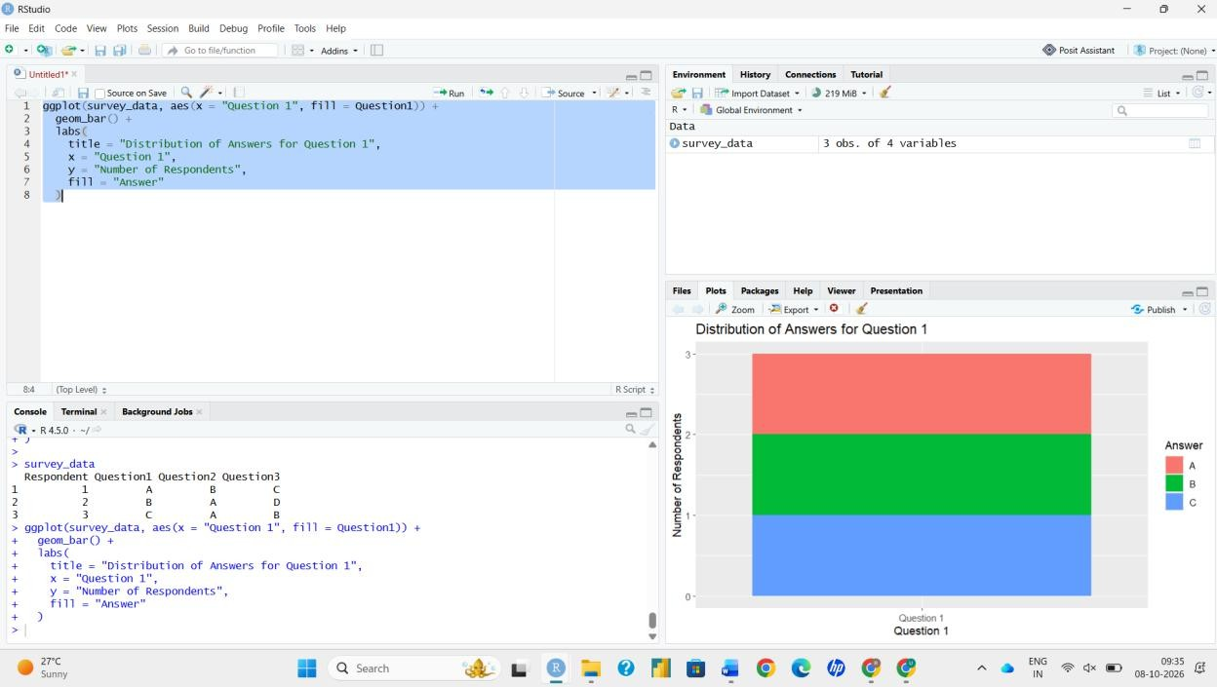
Output 1: Stacked Bar Chart of Question 1 Responses
Observation: Each answer (A, B and C) was chosen by exactly one respondent, so the stacked bar is divided into three equal segments and no option dominates Question 1.

PROGRAM 2: Radar Chart of Overall Response Pattern
Generate a radar chart to visualize the overall pattern of responses across all three questions.

Steps in Tableau:
- Tableau has no built-in radar chart, so it is built from a path/polygon mark using calculated fields.
- Prepare the response count summary below (answers counted per question) as a second sheet or by pivoting Question 1-3 into Question / Answer columns.
- Create calculated field Axis Index: CASE [Question] WHEN "Question 1" THEN 0 WHEN "Question 2" THEN 1 ELSE 2 END.
- Create Angle = [Axis Index] * 2 * PI() / 3, then X = [Count] * COS([Angle]) and Y = [Count] * SIN([Angle]).
- Drag X to Columns and Y to Rows, set the mark type to Line (or Polygon), put Option on Color and Axis Index on Path.
- Repeat the first axis point at the end of each series to close the shape, add axis labels (Question 1-3) and the title "Overall Response Pattern".

Response count summary (used for the radar chart):

Answer Option | Question 1 | Question 2 | Question 3
A | 1 | 2 | 0
B | 1 | 1 | 1
C | 1 | 0 | 1

Answer Option | Question 1 | Question 2 | Question 3
D | 0 | 0 | 1
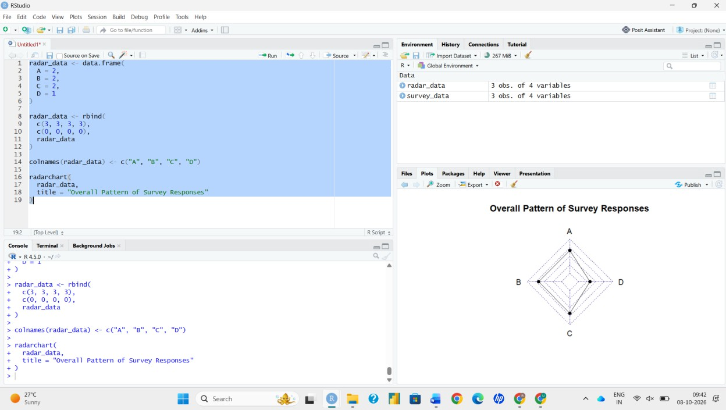
Output 2: Radar Chart of Survey Response Pattern
Observation: Option A is strongest on Question 2 (chosen by 2 of 3 respondents), while option B is the only answer chosen once on every question. Question 3 shows the most varied answers (B, C and D each once), so responses are spread out rather than concentrated.

PROGRAM 3: Table of Survey Responses
Build a table to show the survey response data for each respondent. Label the table elements.

Steps in Tableau:
- Create a new sheet named "Survey Table".
- Drag Respondent to Rows.
- Pivot Question 1, Question 2 and Question 3 (or use Measure Names) and drag the question names to Columns.
- Drag the answer values to Text so each cell shows the respondent's answer.
- Add the title "Survey Responses by Respondent" and keep row and column headers visible.

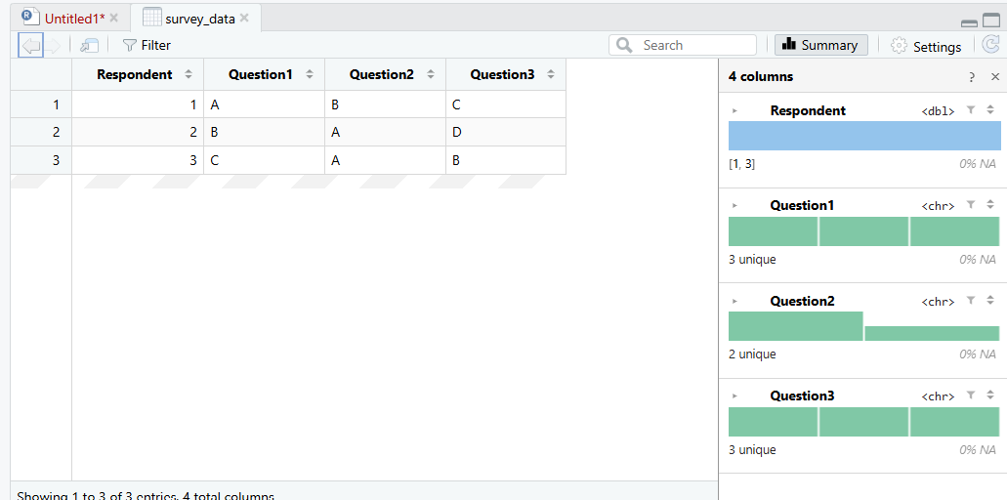
Output 3: Table of Survey Responses
Observation: The table shows the exact answer given by each respondent to each question, which complements the summarised charts.

PROGRAM 4: Interactive Tableau Dashboard
Develop a Tableau dashboard combining the stacked bar chart, radar chart and table for interactive exploration of survey responses.

Steps in Tableau:
- Click New Dashboard at the bottom of the workbook and rename it.
- Set Size to Automatic (or Fixed: Desktop Browser) from the Dashboard pane.
- Drag Q1 Stacked Bar, Radar Chart and Survey Table from the Sheets list onto the dashboard canvas.
- Add a Title (Dashboard > Show Title) and arrange the sheets using Tiled layout containers.
- Select the first chart and click Use as Filter so that selecting an answer segment filters the radar chart and the table.
- Use Dashboard > Actions to add a Highlight action, and enable Show Filters on the sheets for dropdown filtering.
- Click different marks to test interactivity and confirm all views update together.

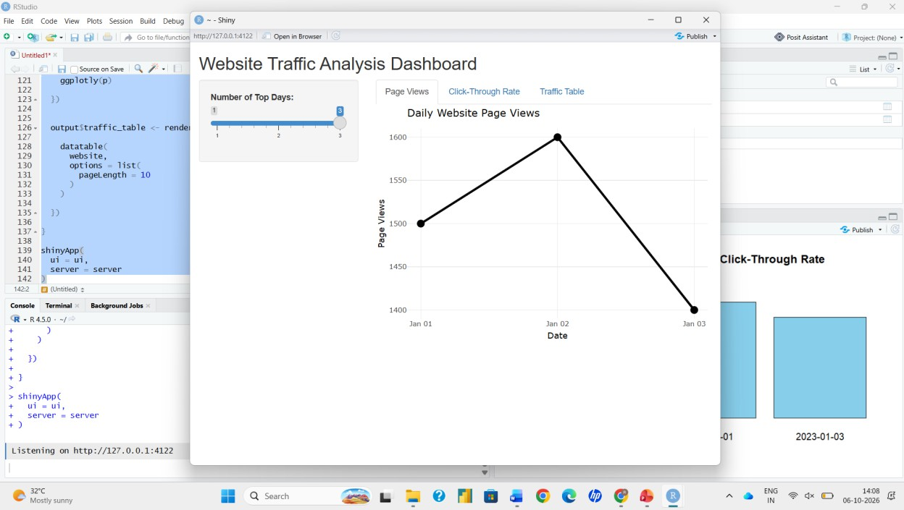
Output 4: Interactive Survey Responses Dashboard
Observation: Clicking an answer in the stacked bar highlights the matching respondents in the table and updates the radar chart, making it easy to explore individual and overall responses.

Procedure
- Load the survey data into Tableau.
- Build the stacked bar chart for Question 1 using Question 1 on Color and count of Respondent.
- Build the radar chart from the response counts using calculated fields for X and Y coordinates.
- Build the table showing each respondent's answers.
- Combine the three sheets in a dashboard and enable filter and highlight actions.
- Test the dashboard by selecting different answers.

Result
The survey results were successfully visualized with a stacked bar chart, radar chart and table, and an interactive Tableau dashboard was created for exploring the responses.

